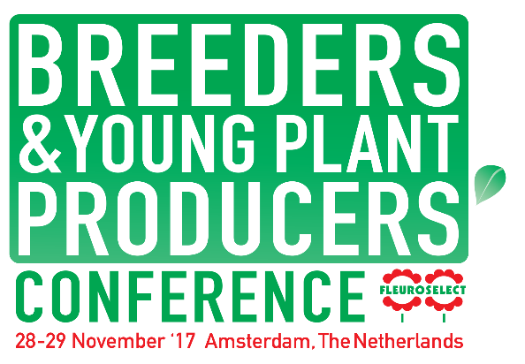

Programme 2017
Tuesday 28th November 2017
10:00 Arrivals & coffee
10:30 Welcome and opening
10:35 Sustainability, the future in packaging, pots, labels etc.
Presentations by: Desch Plantpak and Floramedia
11:35 Coffee Break
11:50 Seed Experience Enkhuizen
Speaker: Henk van Wielink
12:00 Company presentation
Speaker: Danziger
12:30 Lunch
13:45 Bus leaves hotel for Waterdrinker
14:00 Presentations and tours at Waterdrinker – improving collaboration with
Breeders and Growers
16:00 Bus returns to Hotel
16:15 Importance of Green Space for Health and Wellbeing
Speaker: Dr. Jolanda Maas, VU University Amsterdam
17:00 Round up and close
17:30 Drinks reception
18:30 Dinner & networking in hotel

Wednesday 29th November 2017
08:45 Update on Nagoya Protocol
Speaker: Anke van den Hurk - Plantum
09.30 Presentation Pitches – the sector in 2025
Speakers: Thomas Bousart – Dümmen Orange, Leo Hoogendoorn – Florensis, Luc de Bruyne – Retail Specialist, Grower to be determined
10:45 Networking Coffee Break
11:15 Keynote speaker: Dr. James Bellini
Fellow of the World Inspiration Forum
12:30 Close
12:40 Lunch and departure

