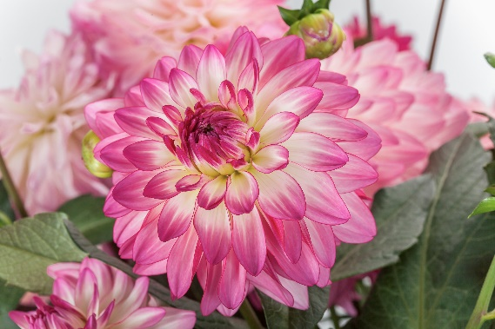

SCORE SHEET FLEUROSTAR CONTEST
Entry : Dahlia x hybrida
Sincerity
Entrant : Syngenta Flowers
Type : Cutting

For giant and dazzling, meet Sincerity from Syngenta Flowers. This new Dahlia’s fully double flowers can reach a diameter of over 20 cm! Sincerity features a multitude of early blooms showcasing large pink and white bi-color flowers with just a touch of yellow at their centre. This newcomer is compact and well-branched, providing a well-shaped backdrop for the showy blooms. Displaying best in mid to late summer and early fall, this Dahlia is a smart choice for landscaping and large planters, or to fill the first holes in perennial borders. Sincerity is an excellent garden performer with massive colour impact that will convince retail and consumers.

Dahlia Sincerity: the king-sized flower!

NAME OF JUDGE : ______________________________________________

ENTRIES VIEWED:
- Online
- At Takii Netherlands

SCORING:

A. How do you rate this variety on Point of Sale Attractiveness 1 2 3 4 5
(Rate on point-of-sale attractiveness where 1 is the lowest rating and 5 is the highest)

B. How do you rate this variety on Commercial Potential 1 2 3 4 5
(Rate on commercial potential where 1 is the lowest rating and 5 is the highest)

C. Does this variety deserve to win the FleuroStar? YES / NO (please circle)
(A FleuroStar winner is an innovation which is able to arouse the interest of the retailer and consumer due to its beauty, expressiveness and exceptional quality i.e. its ‘’Wow” factor)

3. COMMENTS IN SUPPORT OF SCORING:
____________________________________________________________________________________
____________________________________________________________________________________
____________________________________________________________________________________
____________________________________________________________________________________
____________________________________________________________________________________

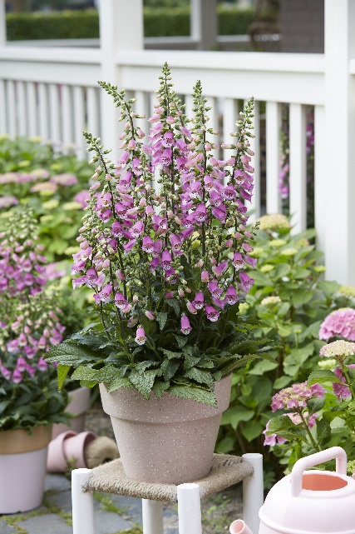

SCORE SHEET FLEUROSTAR CONTEST
Entry : Digitalis x hybrida
Panther
Entrant : Takii
Type : Seed

Always dreamt of recreating that lush look in your green space? Well, look no further. Digitalis x hybrida Panther will be a roaring success thanks to a bushy habit with numerous shoots and flowers. The elegant pink spikes immediately catch the eye while the spotted flower throat with it bold animal pattern gives away the name. This newcomer flowers continuously from early spring to late autumn and attracts pollinators to the garden. Being the first sterile F1 Digitalis from seed, the plant will not reseed itself. The sleek Panther has a compact growth habit reaching a medium height up to 50 – 90 cm and is perfect for large pots or bedding.

Panther, ready to pounce on the perfect spot in your patio or garden.

NAME OF JUDGE : ______________________________________________

ENTRIES VIEWED:
- Online
- At Takii Netherlands

SCORING:

A. How do you rate this variety on Point of Sale Attractiveness 1 2 3 4 5
(Rate on point-of-sale attractiveness where 1 is the lowest rating and 5 is the highest)

B. How do you rate this variety on Commercial Potential 1 2 3 4 5
(Rate on commercial potential where 1 is the lowest rating and 5 is the highest)

C. Does this variety deserve to win the FleuroStar? YES / NO (please circle)
(A FleuroStar winner is an innovation which is able to arouse the interest of the retailer and consumer due to its beauty, expressiveness and exceptional quality i.e. its ‘’Wow” factor)

3. COMMENTS IN SUPPORT OF SCORING:
____________________________________________________________________________________
____________________________________________________________________________________
____________________________________________________________________________________
____________________________________________________________________________________
____________________________________________________________________________________

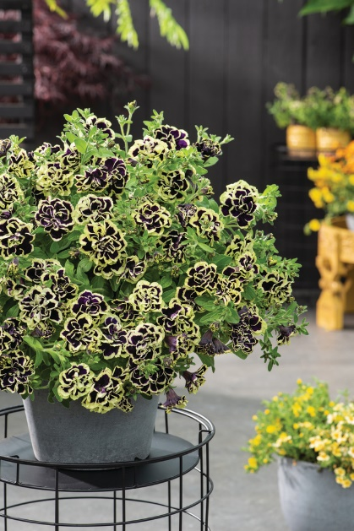

SCORE SHEET FLEUROSTAR CONTEST
Entry : Petunia x hybrida
Mystical® Midnight Gold
Entrant : Florensis/Miyoshi
Type : Cutting

Do you dare to be different? Make a real statement with Petunia Mystical® Midnight Gold. This new introduction features deep purple, almost black double blooms with contrasting lemon borders. The abundance of petals makes each flower look almost like a mini rose. Midnight Gold is a robust plant with exceptional branching. Its profusion of glorious blooms looks wonderful cascading from hanging baskets or containers. In the beds, Mystical® Midnight Gold provides a carpet of blooming, one-of-a-kind colour. The unique colour combination will absolutely stand out on the benches and for consumers who want to differentiate their garden or balcony, Mystical® Midnight Gold is a smart choice.

Mystical® Midnight Gold, for a trendy and modern green space.

NAME OF JUDGE : ______________________________________________

ENTRIES VIEWED:
- Online
- At Takii Netherlands

SCORING:

A. How do you rate this variety on Point of Sale Attractiveness 1 2 3 4 5
(Rate on point-of-sale attractiveness where 1 is the lowest rating and 5 is the highest)

B. How do you rate this variety on Commercial Potential 1 2 3 4 5
(Rate on commercial potential where 1 is the lowest rating and 5 is the highest)

C. Does this variety deserve to win the FleuroStar? YES / NO (please circle)
(A FleuroStar winner is an innovation which is able to arouse the interest of the retailer and consumer due to its beauty, expressiveness and exceptional quality i.e. its ‘’Wow” factor)

3. COMMENTS IN SUPPORT OF SCORING:
____________________________________________________________________________________
____________________________________________________________________________________
____________________________________________________________________________________
____________________________________________________________________________________
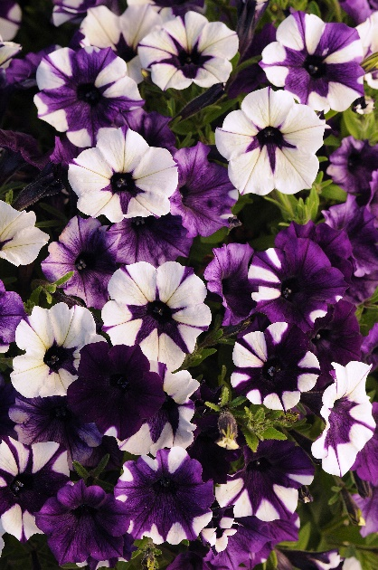

SCORE SHEET FLEUROSTAR CONTEST
Entry : Petunia x hybrida
Shock Wave® Purple Tie Dye
Entrant : PanAmerican Seed
Type : Seed

Petunia hanging baskets are taken to the next level with Shock Wave® Purple Tie Dye! Each plant is blanketed with masses of petite, high-impact flowers while varying temperatures and light conditions will continually create a spectacular assortment of purple, blue and white patterns. Shock Wave® Purple Tie Dye performs equally well in small spaces, baskets, containers, and mixed combos. This trendy Petunia rebounds quickly from the rain and will look fresh again immediately after rain showers. Growers will be impressed by these uniform performers that are as easy to produce as EasyWave. Retail and consumers will be amazed by the high flower count and the ever-changing colour variation.

Shock Wave® Purple Tie Dye, a different basket every day.

NAME OF JUDGE : ______________________________________________

ENTRIES VIEWED:
- Online
- At Takii Netherlands

SCORING:

A. How do you rate this variety on Point of Sale Attractiveness 1 2 3 4 5
(Rate on point-of-sale attractiveness where 1 is the lowest rating and 5 is the highest)

B. How do you rate this variety on Commercial Potential 1 2 3 4 5
(Rate on commercial potential where 1 is the lowest rating and 5 is the highest)

C. Does this variety deserve to win the FleuroStar? YES / NO (please circle)
(A FleuroStar winner is an innovation which is able to arouse the interest of the retailer and consumer due to its beauty, expressiveness and exceptional quality i.e. its ‘’Wow” factor)

3. COMMENTS IN SUPPORT OF SCORING:
____________________________________________________________________________________
____________________________________________________________________________________
____________________________________________________________________________________
____________________________________________________________________________________

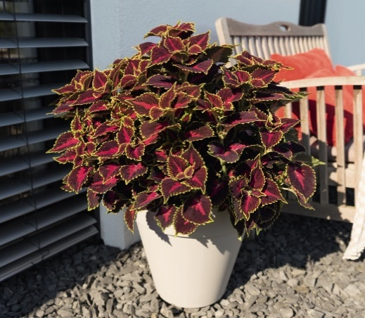

SCORE SHEET FLEUROSTAR CONTEST
Entry : Solenostemon
Main Street Hollywood Boulevard
Entrant : Dümmen Orange
Type : Cutting

Make way for some freaky foliage! Solenostemon Main Street Hollywood Boulevard adds a hint of urban jungle flair to your patio or balcony. The burgundy leaves with magenta pattern in the centre and bright green outer rim absolutely catch the eye. This Coleus can make a true statement as a stand-alone item but is also the perfect complement for flowering ornamentals in mixed containers. Main Street Hollywood Boulevard is very easy to handle, available all-year round and suitable for both indoor and outdoor use. This newcomer will convince retail with excellent shelf life whereas consumers will be impressed with its excellent garden performance.

Main Street Hollywood Boulevard, the leafy star for your green space.

NAME OF JUDGE : ______________________________________________

ENTRIES VIEWED:
- Online
- At Takii Netherlands

SCORING:

A. How do you rate this variety on Point of Sale Attractiveness 1 2 3 4 5
(Rate on point-of-sale attractiveness where 1 is the lowest rating and 5 is the highest)

B. How do you rate this variety on Commercial Potential 1 2 3 4 5
(Rate on commercial potential where 1 is the lowest rating and 5 is the highest)

C. Does this variety deserve to win the FleuroStar? YES / NO (please circle)
(A FleuroStar winner is an innovation which is able to arouse the interest of the retailer and consumer due to its beauty, expressiveness and exceptional quality i.e. its ‘’Wow” factor)

3. COMMENTS IN SUPPORT OF SCORING:
____________________________________________________________________________________
____________________________________________________________________________________
____________________________________________________________________________________
____________________________________________________________________________________

